

IT Services Proposal

Confidential Example



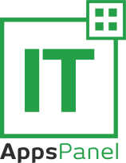




Commercial in Confidence Information
IT Services Proposal Template
W: www.invarosoft.com E: sales@invarosoft.com
Page 2

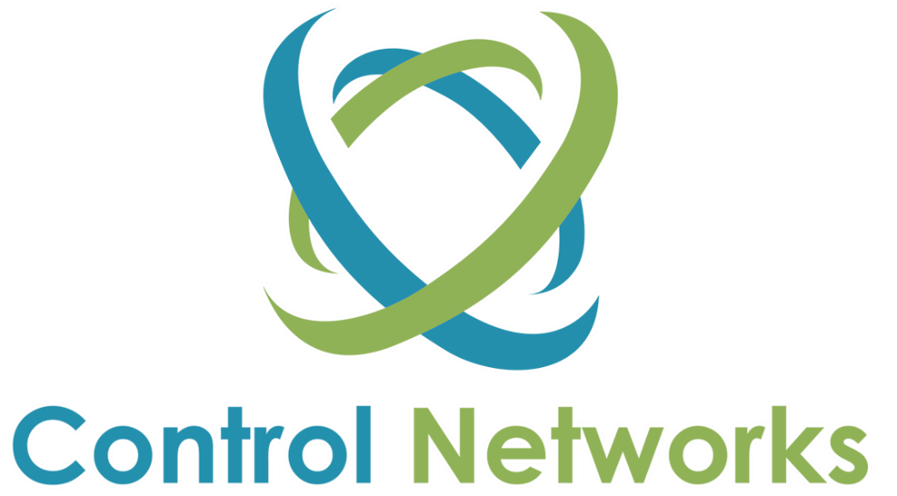

#Insert Client Logo#



MANAGED IT SERVICES PROPOSAL
##companyname##

Monday, 9 March 2020

##contactfirstname## ##contactlastname## ##Company Name## ##postaladdressL1## ##postaladdressL2##

Managed IT Services Proposal

Dear ##contactfirstname##,

Thank you for the opportunity to present the services of Control Networks.

Brief Overview
Control Networks is an award-winning mid-size outsourced IT services provider.

Clients sized 10-250 staff partner with ##Company Name## because they need a midsize MSP to deliver IT ‘peace of mind’ and a one-stop-shop experience.

If your business has outgrown your current IT provider or ‘one man band’ then take advantage of our full service approach powered by over 40 employees. We provide; Support & Maintenance, Consulting, Cloud Services, Microsoft Solutions, Voice & Data, Web Design and Development, Graphic Design, SEO Management and Procurement.



Managed IT Services Proposal

The following proposal will outline how we intend to provide a complete solution for ##Company Name## via our Managed IT Services. The proposal will also provide a detailed overview of our business with references and case studies.

We look forward to the opportunity of partnering with ##Company Name##.

Kind regards, Name
Title
Control Networks

TABLE OF CONTENTS

 | PAGE
1. OVERVIEW | 4
2. WHY CHOOSE US? | 5
3. HOW ARE WE DIFFERENT? | 6
4. OUR SERVICES | 8
5. OUR CLIENTS | 9
6. YOUR TEAM | 11
7. MANAGED SUPPORT OPTIONS | 12
8. SOLUTION BUILDER | 14
9. ENGAGEMENT ROADMAP | 16
10. SPECIAL OFFER | 17
11. CONCLUSION | 18
12. APPENDICES | 19
12.1) Control Networks Case Study Brochure | 19

1. Overview
1.1) Overview

##Company Name## is looking for an alternate IT Services Provider to provide cost effective Managed IT Services as well as proactive consulting and advice.
The following proposal will outline the services and relevant associated costs which can be provided by Control Networks to deliver a suitable & flexible solution for the IT requirements for ##Company Name##.

Your Current IT Issues
The current issues which have been explained include;

- Lack of proactive support by incumbent supplier
- IT systems are not providing suitable solution to business requirements.
- Response times for IT support & consulting is slow.
- Not a one-stop shop.

You’re Looking For
A one-stop-shop IT outsourcing partner who will provide strategic input into your future needs.

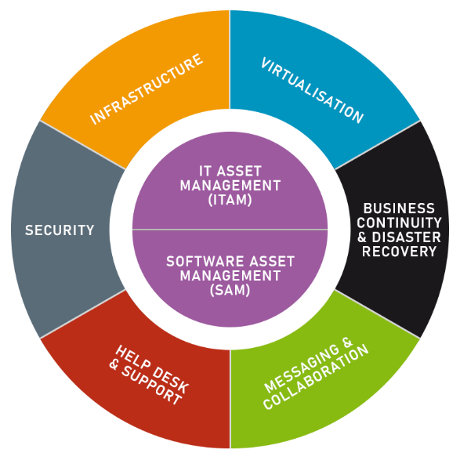

2. Why Choose Us?
2.1) Your Value

Choosing to partner with Control Networks really comes down to the value we can provide you and your business.

Peace of Mind  - 25 Years’ Experience  - 70% of Clients with Control Networks for 10+ Years  - Innovative IT Support Software (ControlSuite)  - 24x7 Support Desk | 
Business Continuity  - Proactive IT Roadmaps & Planning  - Your Disaster Recovery (DR) Plan is #1!  - Dedicated Network Operations Centre (NOC) | 

Systems Visibility  - Monthly Reporting for Network & Support  - Client Web Portal for Complete Systems Visibility  - 24x7 Monitoring using Kaseya, PRTG & ControlMon | 

Cost Containment  - Predictable Fixed Cost Monthly IT Support Plans  - 3-5-year Solution Focus  - We Only Invoice after Approval  - Scalable & Flexible | 



Our expectation is that ##Client Name##:
- Understands our value to your organisation,
- Is willing to make our partnership successful; and,
- Is willing to invest in your IT.

How are we Different?
3.1) Your Peace of Mind, Inspires Our Innovation!

We differentiate ourselves and deliver ‘IT Peace of Mind’ by using our award-winning innovative software & systems.

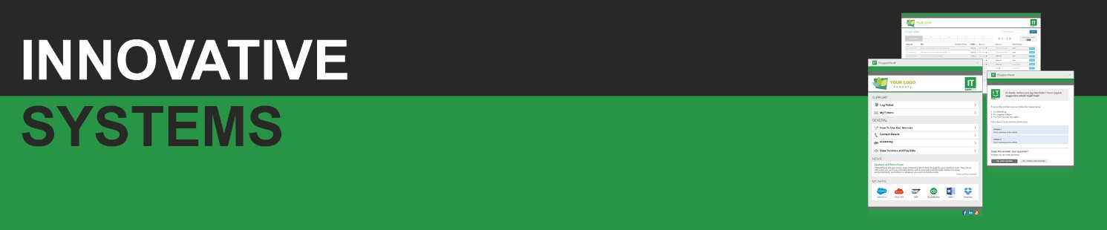

 | ITSupportPanel  A desktop & mobile App which makes changing IT Providers Easy. Reduce user support calls by 50% and improve staff productivity with easy Ticket Logging, Self- Service Bots, Push Notifications, Approval System, News, Surveys & Automation.

 | Ticket Portal & Ticketing System  Innovative Ticket Portal, WorkFlow & Client Notification System for Complete Visibility.

 | Monthly Report  Monthly Network & Service Desk Report for Accountability.

 | 24x7 Monitoring  Proactive 24x7 Systems Monitoring & Management with our powerful Remote Monitoring & Management System (RMM)

 | One Pane of Glass CRM  An Innovative CRM that ensures we’re Fast & Accurate and have all your information at our fingertips.!

 | Quarterly Review  Proactive consulting to ensure we deliver IT Peace of Mind.

 | Trend Analysis  Proactive Trend Analysis to solve problems, not symptoms!

 | The Control Networks Way  Our Proven Processes & Procedures are Systemised to Deliver a Premium Experience Every Time!

- Our Services
4.1) A One Stop Shop

We provide a one-stop shop IT outsourcing service to Small and Medium Businesses with 10-250 employees.

IT Support & Maintenance  - Desktop Management  - Server Management  - Cloud Management  - Network Management | 

Consulting & Projects  - Network Design & Consulting  - Project Management & Installation  - Relocations | 

Solutions  - Archiving  - Backup & Disaster Recovery  - Email  - Files & Folders  - Redundancy  - Security | 

Cloud  - Microsoft Office365  - Infrastructure-as-a-Service (IaaS)  - Desktop-as-a-Service (DaaS)  - Amazon Web Services (AWS)  - Microsoft Azure  - Backup & Disaster Recovery (DR)  - Web & DNS Hosting | 

Internet
- Internet
- VPN & WAN Solutions
- Wireless

Procurement  - Hardware & Software Procurement  - Licensing Management  - Disposal & Recycling | 

5.1) Our Clients

Leading businesses have chosen to outsource their IT requirements to Control Networks. We support over ##number## desktops and ##number## servers for over ##number## clients.
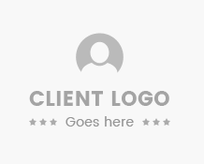

5.2) Speak to Our Clients

##contactfirstname## please feel free to contact the following reference clients who will be happy to discuss our managed IT services.

CITY 1
Company Name (# Users) Name – PHONE NUMBER
Company Name (# Users) Name – PHONE NUMBER
Company Name (# Users) Name – PHONE NUMBER
Company Name (# Users) Name – PHONE NUMBER
Company Name (# Users) Name – PHONE NUMBER
Company Name (# Users) Name – PHONE NUMBER
Company Name (# Users) Name – PHONE NUMBER
Company Name (# Users) Name – PHONE NUMBER

CITY 2
Company Name (# Users) Name – PHONE NUMBER
Company Name (# Users) Name – PHONE NUMBER

CITY 3
Company Name (# Users) Name – PHONE NUMBER



Your Team
6.1) Your Team

Control Networks has invested in the best talent to deliver a premium outsourced IT service.
To deliver a fully outsourced IT department to ##Company Name## your team will include the following departments providing support, consulting and proactive IT management.

Service Desk
Team Members: 16
Skill Set: Level 1 – 4
Qualifications: Diploma IT, CCNA, MCSE, Apple Certified

Engineers
Team Members: 10
Skill Set: Level 1 – 4
Qualifications: Diploma IT, CCNA, MCSE, Apple Certified, Project Management Diploma

Projects & Consulting
Team Members: 5
Skill Set: Level 3 – 4
Qualifications: Diploma IT, CCNA, MCSE, Apple Certified

Client Services, Sales & Accounts
Team Members: 10
Skill Set: Customer Service, Project Coordination, Pre-sales Consulting

Management Team
Team Members: 4



Support Plan Options
7.1) Investment Comparison

We have developed three (3) customisable Support Plan options for your outsourced IT requirements.

Managed Support Plans
Inclusions & Options | Silver Support | Gold Support | Platinum Support
Managed Support
User/Device (Quantity) | $55  per/user/device/month | $65  per/user/device/month | $80  per/user/device/month
Server Management (Quantity) | $95  per/server/month | $195  per/server/month | $395  per/server/month
Cloud Management (Quantity) | $95  per/solution/month | $195  per/solution/month | $395  per/solution/month
Network Management (Quantity) | $195  per/site/month | $295  per/site/month | $395  per/site/month
Managed Advisory | $95  per month | $195  per month | $395  per month
1st Additional Device | ✓ | ✓ | ✓
Unlimited Remote Support via Helpdesk During Business Hours | ✓ | ✓ | ✓
Network Audit – 1st Engagement | ✓ | ✓ | ✓
Licensing & Renewal Management | ✓ | ✓ | ✓
Managed Procurement – Hardware & Software (All Vendors) | ✓ | ✓ | ✓
Patch Management | ✓ | ✓ | ✓
Backup Management | ✓ | ✓ | ✓
Third Party Liaison | ✓ | ✓ | ✓
24/7 Monitoring | ✓ | ✓ | ✓
Dedicated Account Manager | ✗ | ✓ | ✓
Onsite Support | ✗ | ✓ | ✓
Desktop Rebuilds | ✗ | ✗ | ✓
Dedicated CTO Service | ✗ | ✗ | ✓
Managed Advisory
Dedicated Advisory Team | ✓ | ✓ | ✓
Technology Roadmap | ✓ | ✓ | ✓
Network Recommendations | ✓ | ✓ | ✓
New Technology Demonstration | ✗ | ✓ | ✓
Cloud Services Review | ✗ | ✗ | ✓

NerdSuite – Innovative IT Support Software
ITSupportPanel - Desktop Support Application | ✓ | ✓ | ✓
Server, Desktop, Network Monitoring & Maintenance | ✓ | ✓ | ✓
Monthly Network & Support Report | ✓ | ✓ | ✓
Quarterly Network Audits & IT Reviews | ✓ | ✓ | ✓
Ticketing & Workflow System | ✓ | ✓ | ✓
Client Management Database | ✓ | ✓ | ✓
Client Web Portal | ✓ | ✓ | ✓
Trend Analysis | ✓ | ✓ | ✓
Coverage
After Hours Support | Support Pack | Support Pack | ✓
National On-Site Support | Support Pack | Support Pack | Support Pack
Cloud & Security
Managed Endpoint Security | $5  per/user/device/month | $5  per/user/device/month | ✓
Managed Email & Web Security | Custom | Custom | Custom
CryptoAlert | Custom | Custom | Custom
O365, IaaS, Google, Web Hosting | Custom | Custom | Custom
Cloud Backup & DR | Custom | Custom | Custom
Internet
ADSL, SHDSL, EOC, WIRELESS, FIBRE | Custom | Custom | Custom
Total Investment
Monthly Managed Support (ex GST) | $ | $ | $
Notes & Terms
- Control Networks quoted prices exclude GST.
- Infrastructure must be confirmed for final pricing.
- Please see our Managed Support Plan Application Form for further detail on our pricing.
- Networking management is based on how much physical infrastructure you have under this category.
- Silver Managed Support package must purchase a minimum support pack of five (5) hours to cover on-site work and desktop rebuilds.
- 24x7 Support for the Platinum Package includes 24x7 support for Severity 1 Issues only. If you would like 24x7 desktop support, you will require an after-hours support pack.

- Solution Builder
8.1) Solution Builder Matrix

The following represents our proprietary method for ensuring our IT Solutions meet our client’s budget & requirements – it’s called ‘Solution Builder’.

Solution Builder
Category | Good | Better | Best | Client Preferred
Systems Architecture
Servers | Onsite | Onsite/Cloud | Cloud
Domain Controller | Onsite | Onsite/Cloud | Cloud
Files and Folders | Onsite | Onsite/Cloud | Cloud
Email | Exchange | Exchange/O365 | Hosted Exchange/O365
Applications | Onsite | Onsite/cloud | Cloud
Software & Licensing
Licensing model | Upfront | Upfront/Monthly | Monthly
Backup
Backup solution | Tape/Offsite Replication | Tape/Offsite Replication/Cloud Backup | Included
Network
Networking Equipment Required? | Yes | Yes | Yes
Portal
Access Portal | IT AppsPanel | IT AppsPanel | RemoteApp or RDS / CITRIX
Internet
Internet Required | ADSL/EoC/Fibre | EoC/Fibre/WAN | EoC/Fibre/WAN
Support
Desktop, Network, Cloud | Monthly | Monthly | Included
Investments
Pricing Model | Upfront | Upfront and Monthly | Monthly
Who does this suit?
Suits | SMB  One Office | SMB  Multiple Offices | SMB/Enterprise  Multiple Offices, Fast Growth

8.2) Technology Roadmap

Once we have designed a solution, we develop a 12 month ‘road map’ to ensure you have visibility of your IT goals, expectations and projects.



- Engagement Roadmap
9.1) The Journey After You Select ##companyname##

We understand that changing IT providers is a tough decision and can be a challenging process. That is why we do all the hard work so you can focus on your business.

Your Job | Our Job
#Insert Company Logo# | 
- Sign Support Plan Agreement  - Meet Our Team  - Relax! | - Create Email to Inform Existing Provider  - Obtain network Information from Existing IT Provider  - Client Engagement Meeting  - Support Systems Setup  - CRM Information Upload  - Develop Client Introduction Document  - Network Audit & Asset Registry  - Staff Engagement Meeting / Show Video  - Create Standard Operating Environment (SOE) Document
Support Commences (2-4 Weeks)
- Present Audit Results (2-4 Weeks)
- State of Play Meeting (8-12 Weeks)

- Partnership Incentive
10.1) Partnering with eNerds means ‘Confidence’

Control Networks is so confident you will love our innovative service we have devised the following partnership incentive for you to consider.
Sign a Gold or Platinum Managed Support Plan Agreement by ##Insert Date## and get:

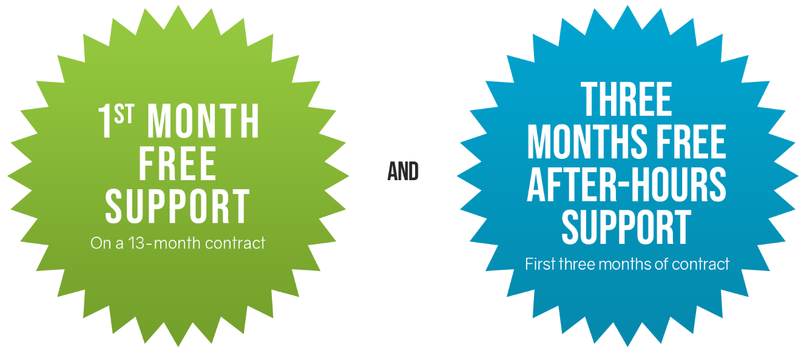

N.B. The partnership incentive is confirmed once the client selects a managed support plan. Control Networks reserves the right to remove this offer at any time.

10.2) Take Advantage of the Offer

To take advantage of this offer all you need to do is sign our managed support agreement before ##Insert Date##.
We look forward to you joining other successful businesses who have chosen to partner with Control Networks.

- Conclusion
11.1) Conclusion

Thank you for the opportunity to discuss your requirements and present our IT Services Proposal for ##Company Name##.
When you decide to partner with Control Networks, you get the 3P’s of success and a 10 out of 10 experience:

Peace of Mind – Mitigate risk through our proactive consulting and proven support systems to deliver business continuity, systems availability and cost containment.

Productivity – Through the use of ITSupportPanel, all staff can access support quickly and efficiently. It reduces their time on the phone by up to 50%!

Profit – Through robust, long term solutions that “just work” we reduce downtime and enable your staff to simply get on with their day to day activities.



##contactfirstname##, we look forward to the opportunity of partnering with ##Company Name## in ##year## and beyond.

If you have any questions, please contact me on ##phone number##.

Kind regards,

Sales Manager Name Title
Control Networks

- Appendices

12.1) Case Study Brochure




##Company Name## Commercial in Confidence Information
IT Services Proposal Template
W: www.invarosoft.com E: sales@invarosoft.com
Page 20

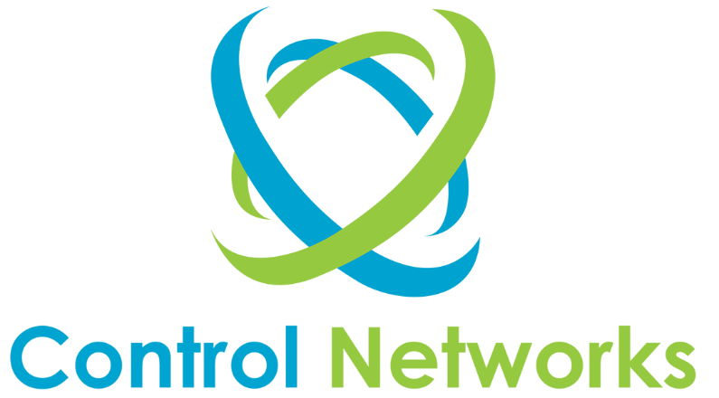

Contact Us
03 9387 1666
Invarosoft Pty Ltd
Address Details

##Company Name## Commercial in Confidence Information
IT Services Proposal Template
W: www.invarosoft.com E: sales@invarosoft.com
Page 21

www.invarosoft.com
ITSM Customer Experience Platform





IT Services Proposal

Confidential Example

